Sunday, December 18 – Pastor and Assistant(s)

+ Gathering +
The Holy Spirit calls us together as the people of God.

PRELUDE

WELCOME

OPENING SONG “O Come O Come Emmanuel” ELW #257-all Verses

ADVENT WREATH LIGHTING “Light One Candle to Watch for Messiah” Verses 1-4”

CONFESSION & FORGIVENESS Pastor: Blessed be the Lord, the God of Israel, who alone does wondrous things.
(congregation response in bold) Congregation: Blessed be God’s name forever. Amen.

P: Beloved, now is the time to wake from sleep. Let us confront our sins, and confess them to the one who is merciful and just.
Silence is kept for reflection.
God, of new beginnings,

C: we confess that we have not welcomed your holy reign. We have strayed from your paths. We prepare for war instead of peace. We dishonor one another and your creation. Purify us with your refining fire and set us again on your way of love, that we may bear fruit worthy of repentance, and welcome your coming among us. Amen.

P: People of God, a new thing is growing in our midst, a tender branch, a living sign. By water and the Spirit you are joined to this wonder. You have put on ☩ Christ, and your sins have been washed away. Rejoice in the way of the Lord.

C: Amen.

GREETING AND PRAYER C: God of promise, you made a commitment to Joseph that you would
OF THE DAY make Jesus a savior to all. Renew your commitment with us, so that all may know the saving grace of your son, Jesus. We pray these things in the name of Jesus Christ, our Savior and Lord. Amen.

ADVENT VIDEO “LOVE”

+ Word +
God speaks to us in scripture reading, preaching, and song.

BOOKS OF THE BIBLE New Testament – Filled in

BIBLE READING AND THEME Matthew 1:18-25 “Jesus as Immanuel”
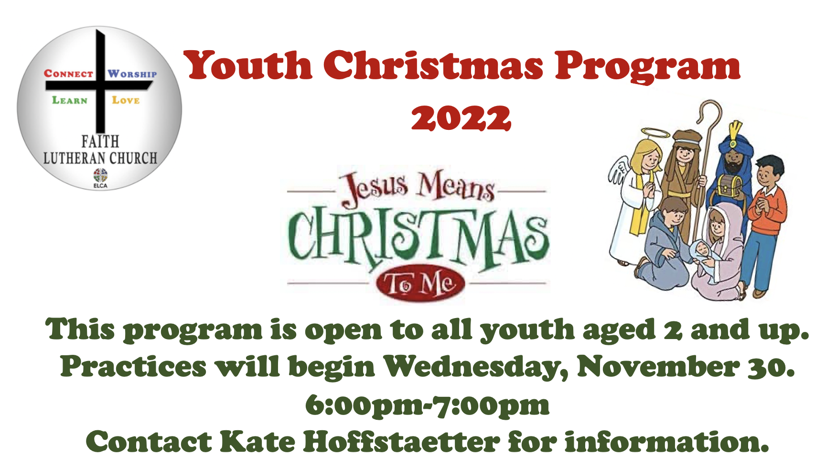

CHILDREN’S CHRISTMAS
PROGRAM

APOSTLES’ CREED L: We profess our faith through the words of the Apostles’ Creed.

C: I believe in God, the Father almighty, Creator of heaven and earth. I believe in Jesus Christ, his only Son, our Lord. He was conceived by the power of the Holy Spirit and born of the virgin Mary. He suffered under Pontius Pilate, was crucified, died, and was buried. He descended into death. On the third day he rose again. He ascended into heaven, and is seated at the right hand of the Father. He will come again to judge the living and the dead. I believe in the Holy Spirit, the holy Christian Church, the communion of saints, the forgiveness of sins, the resurrection of the body, and the life everlasting. Amen.

PRAYERS OF INTERCESSION
L: As we prepare for the fullness of Christ’s presence, let us pray for a world that yearns for new hope.
A brief silence.
L: God our shepherd, let your Spirit move with power throughout the church. Give discernment and wisdom to our bishops, pastors, deacons, and lay leaders. Take away our fear, so that we serve and love, confident that you are guiding us. God, in your mercy,
C: hear our prayer.

L: God our source, awaken us to the beauty of the earth and the marvelous variety of life. Unite humankind in repairing and caring for your creation. Protect creatures and habitats in peril due to rising seas and warming temperatures. God, in your mercy,
C: hear our prayer.

L: God our vision, raise up leaders in every nation who dream of freedom and justice for all people. We pray for the work of international organizations that promote peace and human rights, especially Amnesty International. God, in your mercy,
C: hear our prayer.

L: God our helper, come to the aid of all who cry out to you. Shelter migrants, refugees, and those fleeing war and famine. Bring relief to individuals and families experiencing hunger, homelessness, or impoverishment. Comfort any who are isolated or lonely. God, in your mercy,
C: hear our prayer.

L: God our Emmanuel, you are with us in our life together. We give you thanks for gathering us in worship and fellowship, and we remember those who cannot be present. Watch over those who travel. Heal the sick and speed their recovery. God, in your mercy,
hear our prayer.

Here other intercessions may be offered.

L: God our hope, you bring life out of death, and you promise to be our God forever. Shine upon the faithful who now rest in the fulfillment of your promise and bring us also into your blessed reign of peace. God, in your mercy,
C: hear our prayer.

L: God of our longing, you know our deepest needs. By your Spirit, gather our prayers and join them with the prayers of all your children. In Jesus’ name we pray.
C: Amen.

PASSING OF THE LORD’S PEACE L: The peace of Christ be with you always.
C: And also with you.

+Meal+
God feeds us with the presence of Jesus Christ.

OFFERING

Thank you for supporting the mission of the church as you are able! Electronic donations can be made at
https://bit.ly/2UiQoTj Checks can be also be sent to church: 2370 Bridge Road, Suffolk, VA 23435

OFFERTORY SONG “Away In A Manger”

OFFERING PRAYER L: Eternal God, you make the desert bloom and send springs of water to thirsty ground. Received these simple gifts of bread, wine, and money, and make us messengers of your mercy and love for all in need of your healing and justice. We ask this through Christ our Savior.
C: Amen.
GREAT THANKSGIVING

SONG OF PRAISE “HOLY, HOLY, HOLY” ELW pg 153

THE WORDS OF INSTITUTION (spoken by Pastor)
It is indeed right, our duty and our joy, that we should at all times and in all places give thanks and praise to you, almighty and merciful God, through our Savior Jesus Christ.
You comforted your people with the promise of the Redeemer, through whom you will also make all things new in the day when he comes to judge the world in righteousness.
And so, with all the choirs of angels, with the church on earth and the hosts of heaven, we praise your name and join their unending hymn:

THE LORD’ PRAYER C: Our Father in heaven, holy is your name, your kingdom come, your will be done, on earth as in heaven. Give us today our daily bread. Forgive us our sins as we forgive those who sin against us. Save us from the time of trial and deliver us from evil. For the kingdom, the power, and the glory are yours, now and forever. Amen.

INVITATION TO COMMUNION

COMMUNION SONG “Almost There” duet: Roxanne Parks & James Shiels

POST COMMUNION PRAYER L: Faithful God, in this meal you have remembered your mercy, bringing heaven to earth in the body and blood of Christ. As we wait for the day when all your promises will be fulfilled, sustain us and strengthen us by this holy mystery. Guide us toward your promised future, coming to birth in Jesus Christ our Savior and Lord.
C: Amen

+Sending+
God blesses us and sends us in mission to the world.

THE BENEDICTION P: God the eternal Word, who dwells with us in Jesus, and who holds us in the grace of the Holy Spirit, ☩ bless you now and forever.
C: Amen.

ANNOUNCEMENTS

CLOSING SONG “Joy To The World” ELW #267

DISMISSAL L: Go in peace. Christ is near.
C: Thanks be to God.
Liturgy from ELWorship copyright © 2006 ELCA Admin Augsburg Fortress. Reproduced by Permission. Augsburg Fortress Copyright License 15281-LI

